**Please make sure to save/push all your code in the branch feature-java created in the previous week assignment as part of your github repo rg-assignments**

**Please share your output screenshots in the assignment document along with the github link for each question. Provide an explanation wherever possible as part of your response :-)**



Given:

public class TaxUtil {

double rate = 0.15;

public double calculateTax(double amount) {

return amount * rate;

}

}

Would you consider the method calculateTax() a 'pure function'? Why or why not?

If you claim the method is NOT a pure function, please suggest a way to make it pure.

* Because it **depends on an instance variable rate**, which makes it rely on external state. A pure function should always give the same output for the same input **without depending on or modifying external data**.
* **Make it pure like this:**

public double calculateTax(double amount, double rate) {

return amount * rate;

}

* it depends only on its parameters.
* 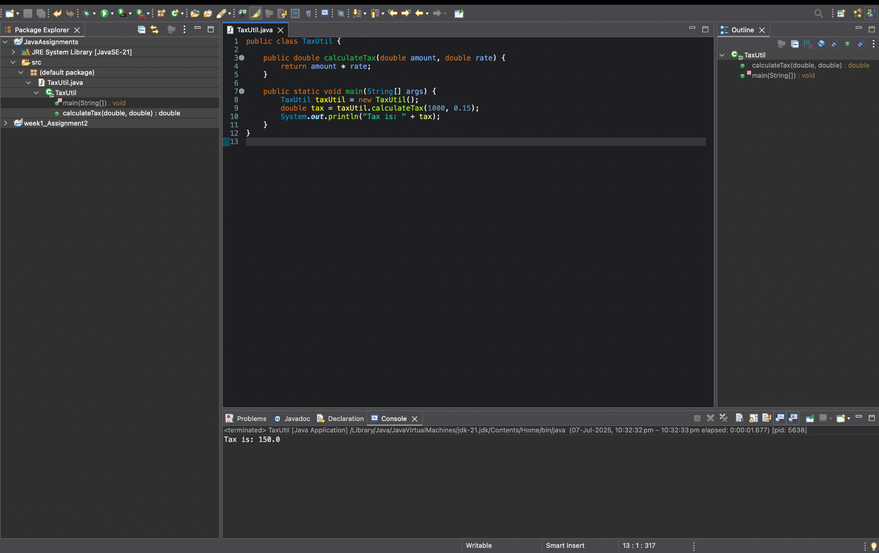

2)

What will be the output for following code?

class Super

{

static void show()

{

System.out.println("super class show method");

}

static class StaticMethods

{

void show()

{

System.out.println("sub class show method");

}

}

public static void main(String[]args)

{

Super.show();

new Super.StaticMethods().show();

}

}

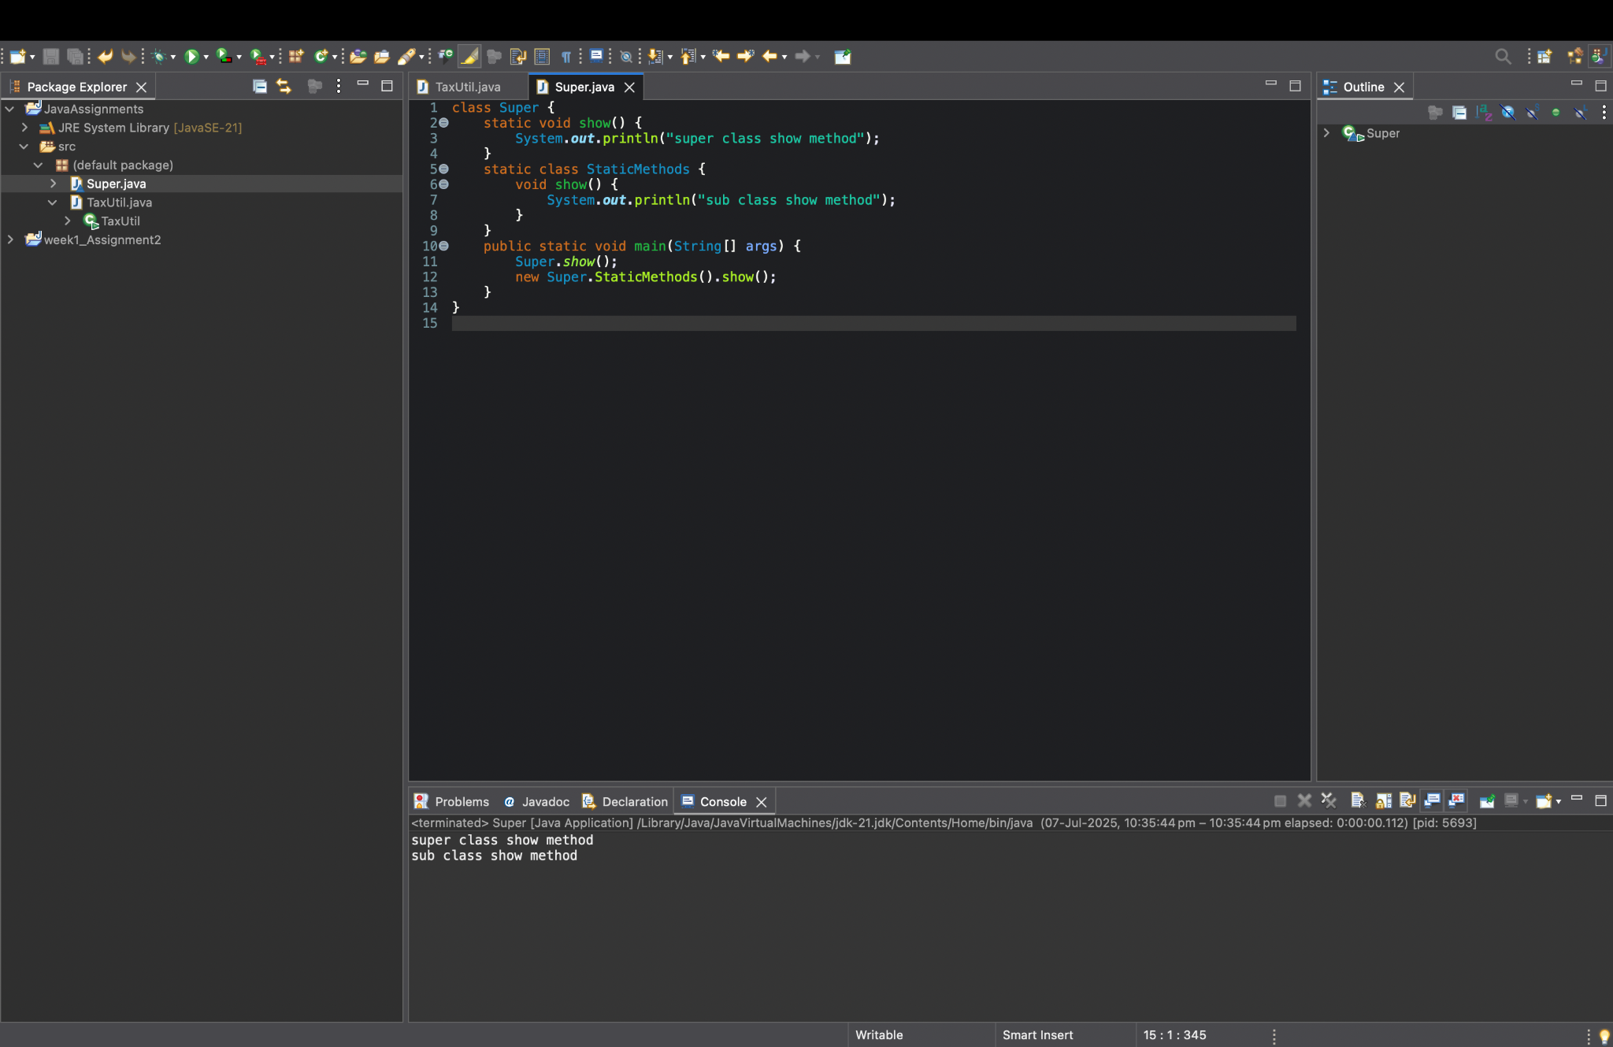

3)

What will be the output for the following code?

class Super

{

int num=20;

public void display()

{

System.out.println("super class method");

}

}

public class ThisUse extends Super

{

int num;

public ThisUse(int num)

{

this.num=num;

}

public void display()

{

System.out.println("display method");

}

public void Show()

{

this.display();

display();

System.out.println(this.num);

System.out.println(num);

}

public static void main(String[]args)

{

ThisUse o=new ThisUse(10);

o.show();

}

}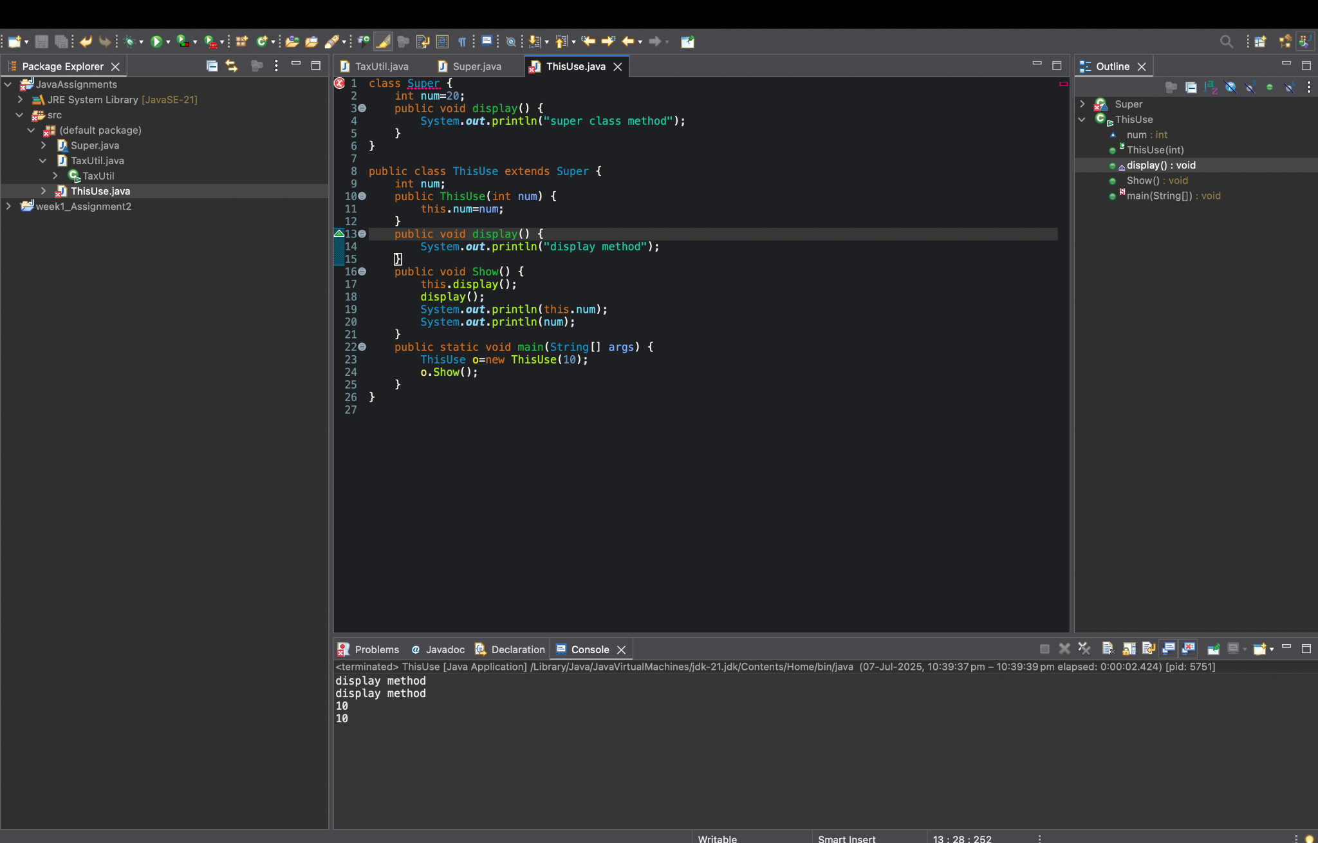

4) What is the singleton design pattern? Explain with a coding example.

* A **singleton pattern** ensures a class has **only one instance** and provides a global point of access to it.
* **Example:**

public class Singleton {

private static Singleton instance;

private Singleton() {} // private constructor

public static Singleton getInstance() {

if (instance == null) {

instance = new Singleton();

}

return instance;

}

}

* We can call Singleton.getInstance() to always get the **same object**
* 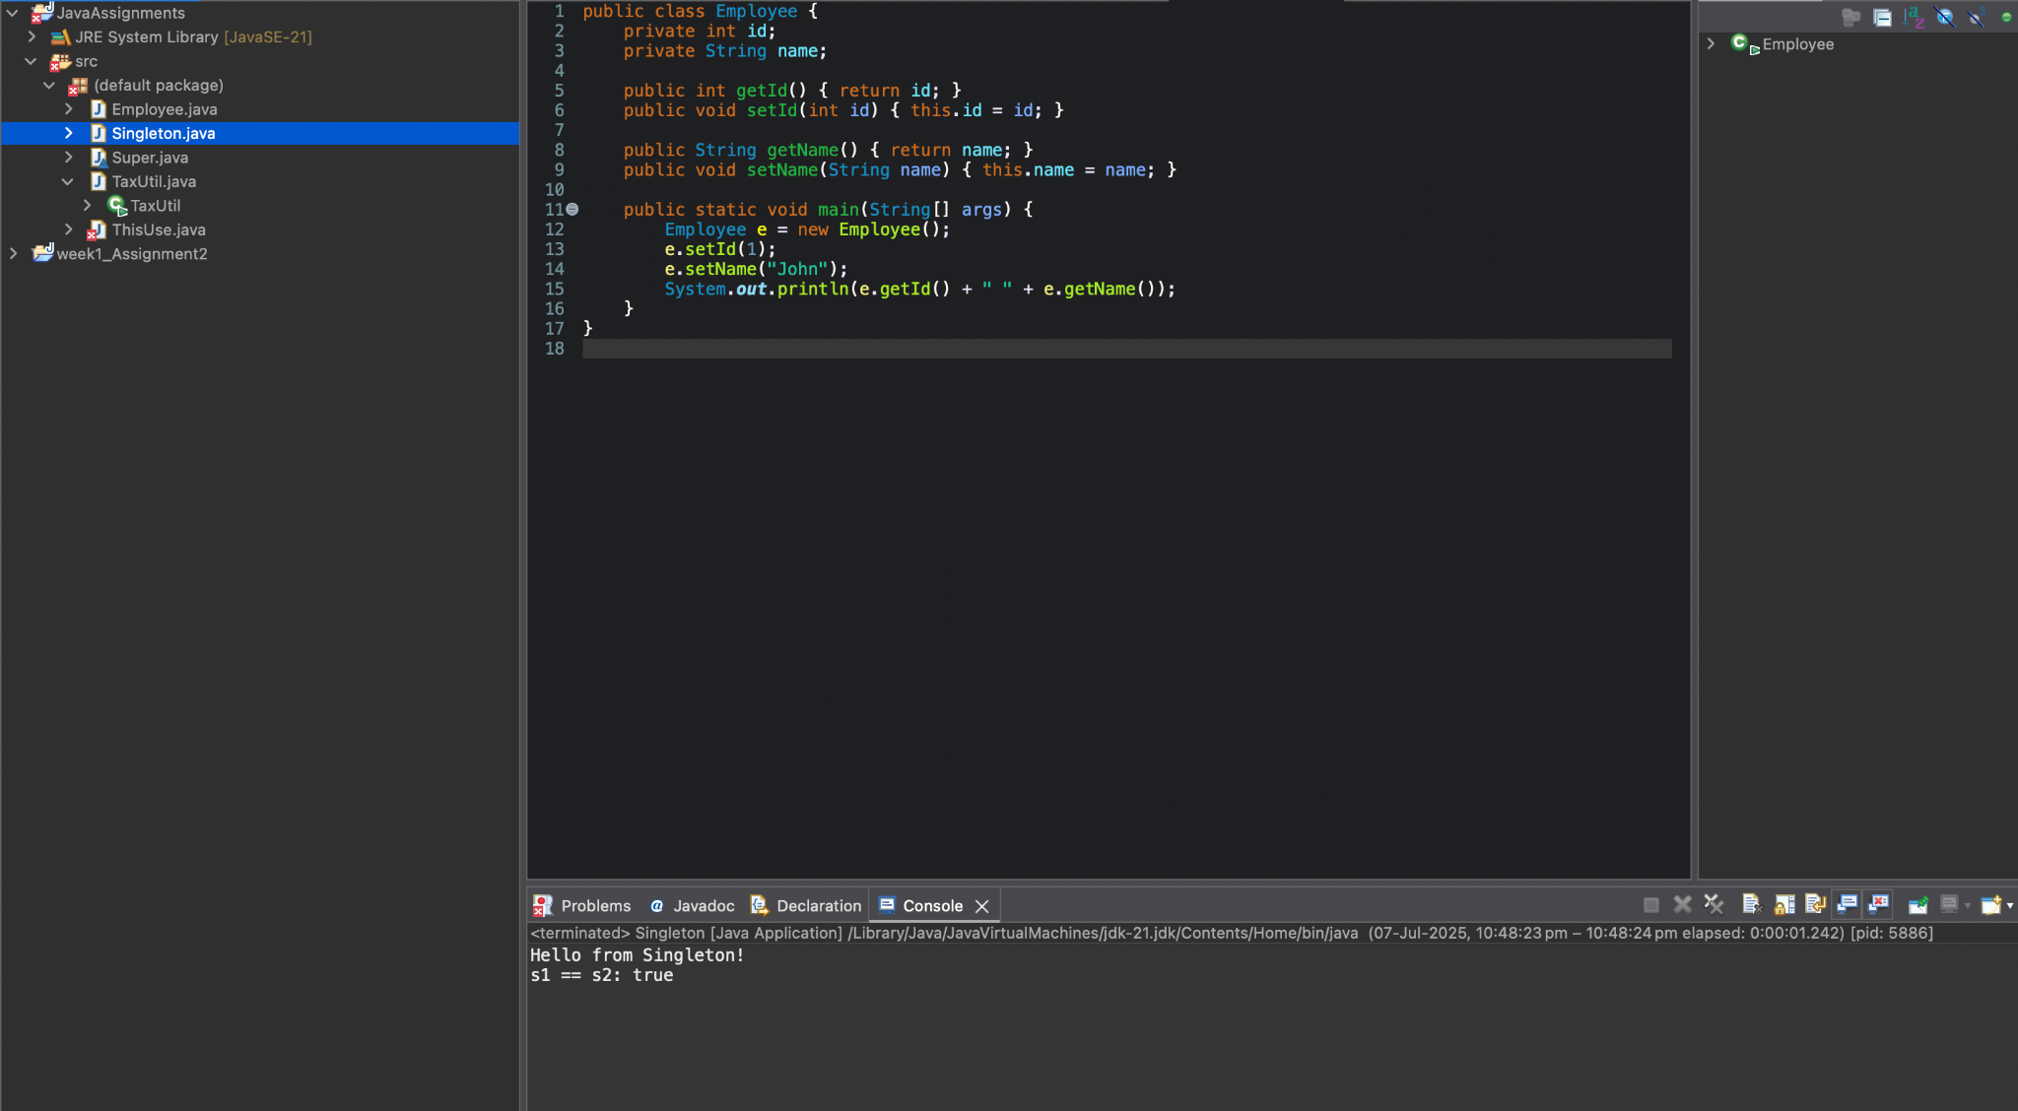

5) How do we make sure a class is encapsulated? Explain with a coding example.

**Encapsulation** means keeping data (fields) private and exposing them via **getters/setters**.

* **Example:**

public class Employee {

private int id;

private String name;

public int getId() {

return id;

}

public void setId(int id) {

this.id = id;

}

public String getName() {

return name;

}

public void setName(String name) {

this.name = name;

}

}

* Fields are private.
* Access is only through public methods.  
  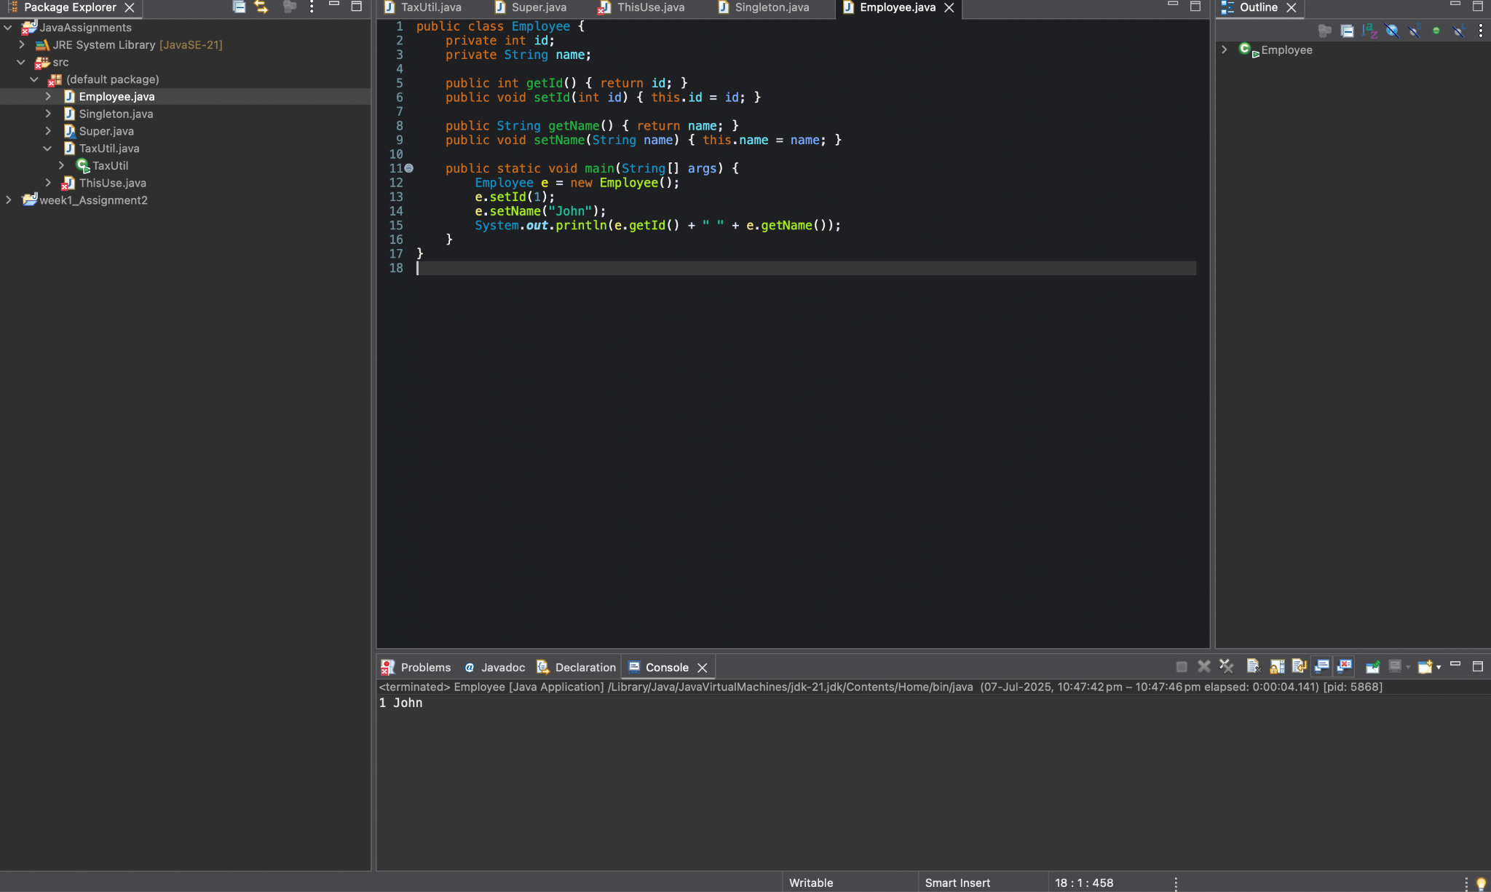

6)Perform CRUD operation using ArrayList collection in an EmployeeCRUD class for the below Employee

class Employee{

private int id;

private String name;

private String department;

}

* **Employee class**

public class Employee {

private int id;

private String name;

private String department;

// constructors, getters & setters

}

* **EmployeeCRUD class**

import java.util.*;

public class EmployeeCRUD {

private List<Employee> employees = new ArrayList<>();

public void addEmployee(Employee e) {

employees.add(e);

}

public void viewEmployees() {

for(Employee e : employees) {

System.out.println(e.getId() + " " + e.getName() + " " + e.getDepartment());

}

}

public void updateEmployee(int id, String newName, String newDept) {

for(Employee e : employees) {

if(e.getId() == id) {

e.setName(newName);

e.setDepartment(newDept);

}

}

}

public void deleteEmployee(int id) {

employees.removeIf(e -> e.getId() == id);

}

}



7) Perform CRUD operation using JDBC in an EmployeeJDBC class for the below Employee

class Employee{

private int id;

private String name;

private String department;

}

import java.util.*;

public class EmployeeCRUDNative {

private Map<Integer, Employee> db = new HashMap<>();

public void create(Employee e) {

db.put(e.getId(), e);

System.out.println("Inserted: " + e);

}

public void readAll() {

db.values().forEach(System.out::println);

}

public void update(int id, String newName, String newDept) {

Employee e = db.get(id);

if (e != null) {

e.setName(newName);

e.setDepartment(newDept);

System.out.println("Updated: " + e);

}

}

public void delete(int id) {

db.remove(id);

System.out.println("Deleted employee with id: " + id);

}

public static void main(String[] args) {

EmployeeCRUDNative crud = new EmployeeCRUDNative();

Employee e1 = new Employee(1, "Alice", "IT");

Employee e2 = new Employee(2, "Bob", "HR");

crud.create(e1);

crud.create(e2);

System.out.println("All employees:");

crud.readAll();

crud.update(1, "AliceUpdated", "Finance");

System.out.println("After update:");

crud.readAll();

crud.delete(2);

System.out.println("After delete:");

crud.readAll();

}

}

